Cooking Up FAMILY Fun

Please join FAMILY, Inc. for a virtual cooking series FULL of kid friendly recipes, stories, and fun activities. Stay connected while socially distant.
Registration is required! Participants will receive a grocery drop-off and Zoom Link prior to the event.

Personal Pizzas Taco Ring Corn Dog Muffins
Thursday, July 30th Thursday, August 27th Thursday, September 24th
10:30-11:30 AM 10:30-11:30 AM 10:30-11:30 AM
OR OR OR
5:00-6:00 PM 5:00-6:00 PM 5:00-6:00 PM
RSVP by 7/23/20 RSVP by 8/20/20 RSVP by 9/17/20
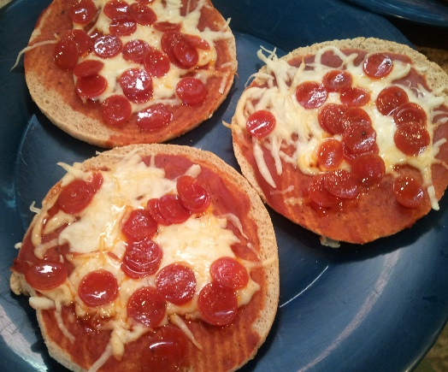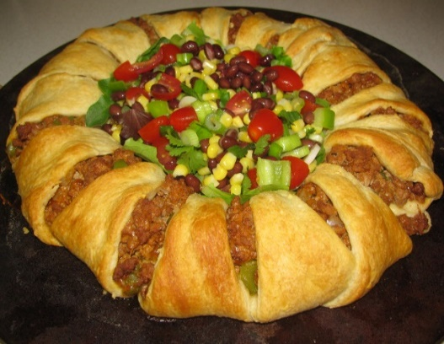

Registration is required!
To register or for more information contact Lauren at (402) 253-6048 or lrollins@familyia.org

